Data lake tables

Lab 2- Investigate Hive’s special columns
Estimated completion time
- 15 minutes

Learning objectives
- This lab will explore Hive’s use of columns and special columns. The goal is to show the kind of metadata captured in special columns, how you can access that data, and some of the formatting that you can apply to the output from these columns. You will then create a test table to simulate testing in real-world scenarios.

Prerequisites
- Student setup - student account

Activities
- Prepare for the exercise
- Understanding special columns in Hive
- Show location of table data
- Return special column values
- Remove duplicate results using DISTINCT command
- Locate results file
- Use common table expression and string functions
- Create table to test hidden columns
- Improve clarity of results
- Add more records

Step 1 - Prepare for the exercise
- Sign in and verify the students role is selected in the upper-right corner.
- Ensure the aws-us-east-1-free Cluster is reporting a Status of Running.
- In the Query editor, select aws-us-east-1-free in the cluster pulldown.

Note: If you did not previously create a schema, execute the following SQL statement. Make sure that you replace yourname with your actual name, or another identifier that you prefer. Only use lowercase characters and numbers; no special characters or spaces.

CREATE SCHEMA students.yourname;

Step 2 - Understanding special columns in Hive
This lab will explore the special columns functionality available for Hive tables.

In addition to defined columns, the Hive connector automatically exposes the metadata for several hidden columns in each table. These include:
- $bucket: Bucket number for this row
- $path: Full file system path name of the file for this row
- $file_modified_time: Date and time of last modification of the file for this row
- $file_size: Size of the file for this row
- $partition: Partition name for this row

This lab will focus on the $path and $file_size hidden columns. Additional hidden columns will be explored in a later exercise.

Step 3 - Show location of table data
Navigate to Query > Query editor and expand aws-us-east-1-free under the list of clusters.

Run the following command to see the location of the table’s data.

SHOW CREATE TABLE lakehouse.global.nation;

Unfortunately, the output does not clarify where this data is located.

Output

CREATE TABLE lakehouse.global.nation (
nationkey bigint,
name varchar(25),
regionkey bigint,
comment varchar(152)
)
WITH (
format = 'ORC',
type = 'HIVE'
)

Step 4 - Return special column values
There are only 25 rows in this table. Let’s find the values of a few of these special columns.

The following code returns the $path, $file_size, and $file_modified_time values, as pictured in the image below.

SELECT
nationkey,
"$path",
"$file_size",
"$file_modified_time"
FROM
lakehouse.global.nation;

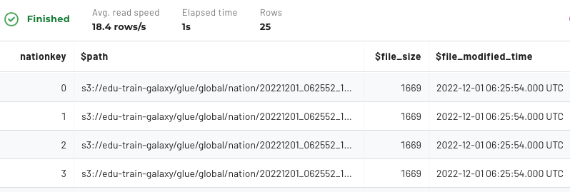

Step 5 - Remove duplicate results using DISTINCT command
The query results pane makes it hard to read the value(s) from the $path hidden column. To fix this, you can remove duplicates and limit the results to show only the column’s value(s) using the DISTINCT command. Try it now and see the difference.

SELECT DISTINCT("$path")
FROM lakehouse.global.nation;

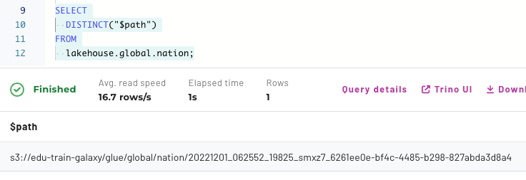

Step 6 - Locate the results file
The results are output to a single file held in an S3 bucket. In this example, the file is located in the s3://edu-train-galaxy/glue/global/nation/ directory.

The images below are from the instructor’s AWS console showing an example of the location and the files list.

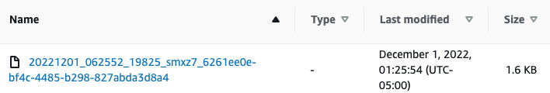

Step 7 - Common table expression and string functions
You can use a common table expression (CTE) and string functions to display the folder location. This makes the path easier to view.

Use the following query to return the path down to the directory that contains the file. The result should resemble the image below.

Note: This SQL is presented as an aid to review the underlying contents on the data lake and there is no need to focus on interpreting it at this time.

WITH
distinct_paths AS (
SELECT DISTINCT
("$path") AS full_path
FROM
lakehouse.global.nation
)
SELECT
REVERSE(
SUBSTRING(
REVERSE(full_path),
POSITION('/' IN REVERSE(full_path))
)
) AS dir_name
FROM
distinct_paths;

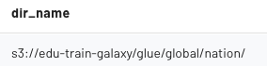

Step 8 - Create table to test hidden columns
Now it’s time to test the hidden columns. To do this, you will need to create a new table using the code below.

USE students.yourname;

CREATE TABLE hidden_cols_test (
row_nbr int, ins_nbr int
);

Now add one record using the INSERT statement. This will create the first file (holding this single record) in the table’s data lake folder.

INSERT INTO
hidden_cols_test (row_nbr, ins_nbr)
VALUES
(1, 1);

Now it’s time to verify that the single file exists in the hidden_cols_test table using the code below.

SELECT
row_nbr, ins_nbr, "$path"
FROM
hidden_cols_test
ORDER BY
row_nbr, ins_nbr;

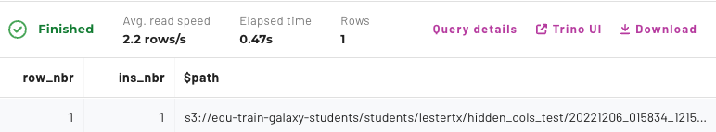

Step 9 - Improve clarity of results
The clarity of the query results displaying this hidden column could still be improved further. Assume that you want to show just the file name. The statement below is an enhancement of the one presented in Step 7 and will display a file name only, without the directory listed.

Note: As before, this SQL is presented as an aid to review the underlying contents on the data lake and there is no need to focus on interpreting it at this time.

--NOTE: Convenience SQL (NO NEED TO REVIEW THIS!!)
WITH
all_rows_file_names AS (
SELECT row_nbr, ins_nbr AS file_nbr,
("$path") AS full_path
FROM hidden_cols_test
)
SELECT
row_nbr, file_nbr,
SPLIT_PART(full_path, '/', 7) AS file_name
FROM all_rows_file_names
ORDER BY row_nbr;

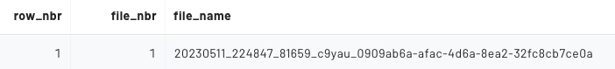

The output above shows us that the first INSERT statement (of a single row) was recorded in a single file.

Step 10 - Add more records
Now it’s time to add results and view the impact on the test tables. Add two more records with a second INSERT statement.

INSERT INTO
hidden_cols_test (row_nbr, ins_nbr)
VALUES
(2, 2),
(3, 2);

Run the Step 9 query again to verify that this second INSERT statement (of two more rows) wrote another file containing both values.

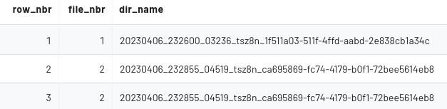

Now add three more records with a third INSERT statement.

INSERT INTO
hidden_cols_test (row_nbr, ins_nbr)
VALUES
(4, 3),
(5, 3),
(6, 3);

Running the Step 9 query one last time verifies this third INSERT statement (of three rows) wrote one final file with all three values.

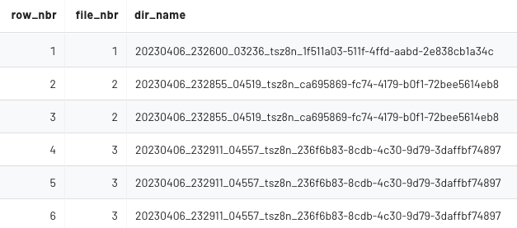

You cannot view S3, but here is a view from the instructor’s AWS console. You can see that the three distinct file names above are exactly how they are stored in S3.

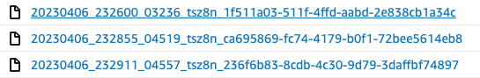

END OF LAB EXERCISE

